New Iberia Research Center
for more information contact:
[Contact Name] at 337.482.XXXX
invites you to its SPRING 2024
Friends & Family Open Day
Saturday, APRIL 20, 2024
8:00 am – 11:00 am
4401 West Admiral Doyle Drive
New Iberia, LA 70560
Please email your RSVP to NIRCrsvp@louisiana.edu or contacting Sarah Hebert at 20331 by April 15th, 2024. Include the following:
- NIRC Family and Friends Day in subject line
- First and last name of each person in your group
- Ages of those 17 and younger. Children must be at least 4 years of age
- Contact email address & phone number

Special notes:
- This is a walking tour. Attendees must wear closed-toe shoes.
- Parking available at NIRC at no cost or in parking lots on Admiral Doyle Drive across from Center.
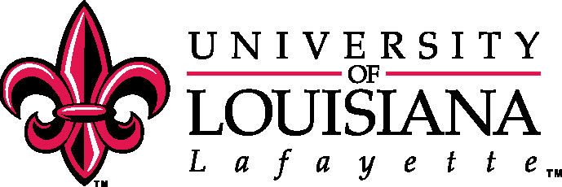
- No photography is allowed. Use of cell phones and electronic devices are not allowed during the tour.

