How to share a Qualtrics survey link with the IRB prior to gaining distribution permission.
Put your survey in preview mode.
In the upper right you will see a Share Preview button.
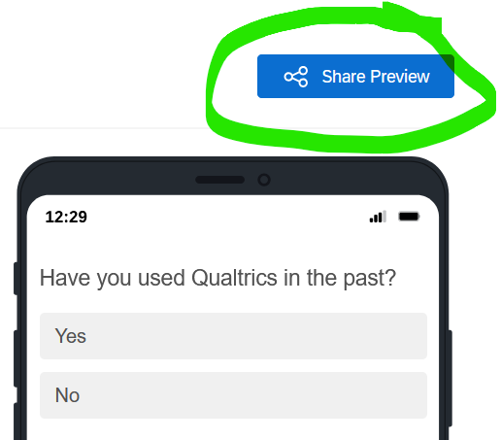
Click the Share Preview button to open the Share Preview window.
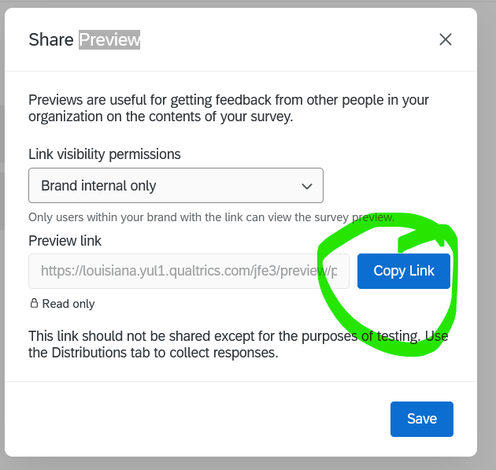
Click the Copy Link button to copy the link to your survey and paste this into the question in the IRB application.

